Week 4 Sentiment Classifier Report
Machine learning basics
Name : Bisma Mazhar
Employee id:AB01
Domain : AI internship
1.Introduction
This week's assignment introduced me to the practical side of Machine Learning. Instead of just reading theory, I got to build a real, working model from start to finish — one that reads a piece of text and predicts whether it carries a positive, negative, or neutral tone.
I used the dataset I had already cleaned in Week 3 as the foundation for this task. The main purpose of this exercise was not just to get a model running, but to actually understand what happens behind the scenes when a machine "learns" from text data.
2. Objective
By the end of this task, I aimed to:
- Get a practical understanding of how classification works in ML
- See the real difference between training a model and testing it
- Learn how to judge whether a model is actually performing well, using proper evaluation metrics
- Build and run a sentiment classifier using scikit-learn
- Generate a final, usable output that clearly shows each post along with its predicted sentiment and confidence score.
3. Tools and Libraries Used
The following tools were used in this project:
- Python → Core programming language
- Pandas → For handling the dataset
- Scikit-learn (sklearn) → For machine learning models
- TextBlob → For generating sentiment labels
4. My Understanding of the Process
- Before this task, "Machine Learning" felt like a vague term. Working through it hands-on made it much clearer. Here's roughly how I'd explain it in my own words:
- A model can't learn anything on its own — it needs examples. So first, I had to give each post in my dataset a label (positive, negative, or neutral) using TextBlob, since the raw data didn't come with any. Once labeled, I split the data into two groups: one the model would learn from, and one I'd keep hidden from it, just to test it honestly afterward.
- The model itself can't read words the way we do, so the text had to be converted into numbers first. Then it was trained on the "learning" portion of the data, and finally tested on the part it had never seen — which is really the only fair way to know if it actually learned something useful, rather than just memorizing.
5. Project Structure
Machine-Learning-Basics/
│
├── data/
│ ├── clean_dataset.csv
│ └── predictions.csv
│
└── ml_basics.ipynb
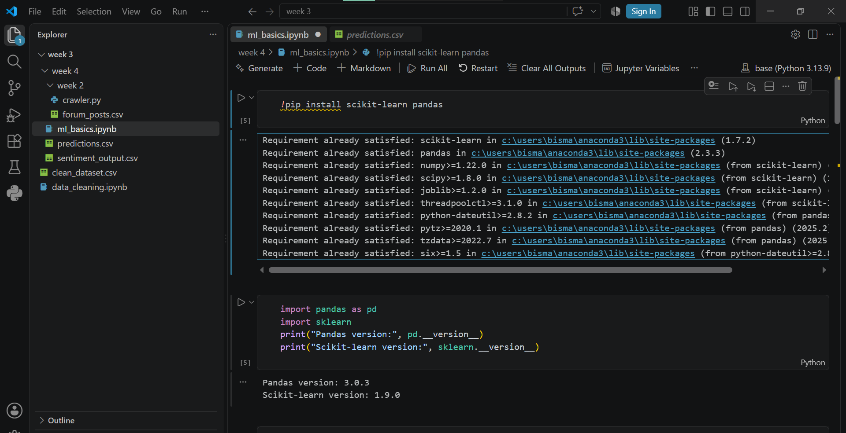
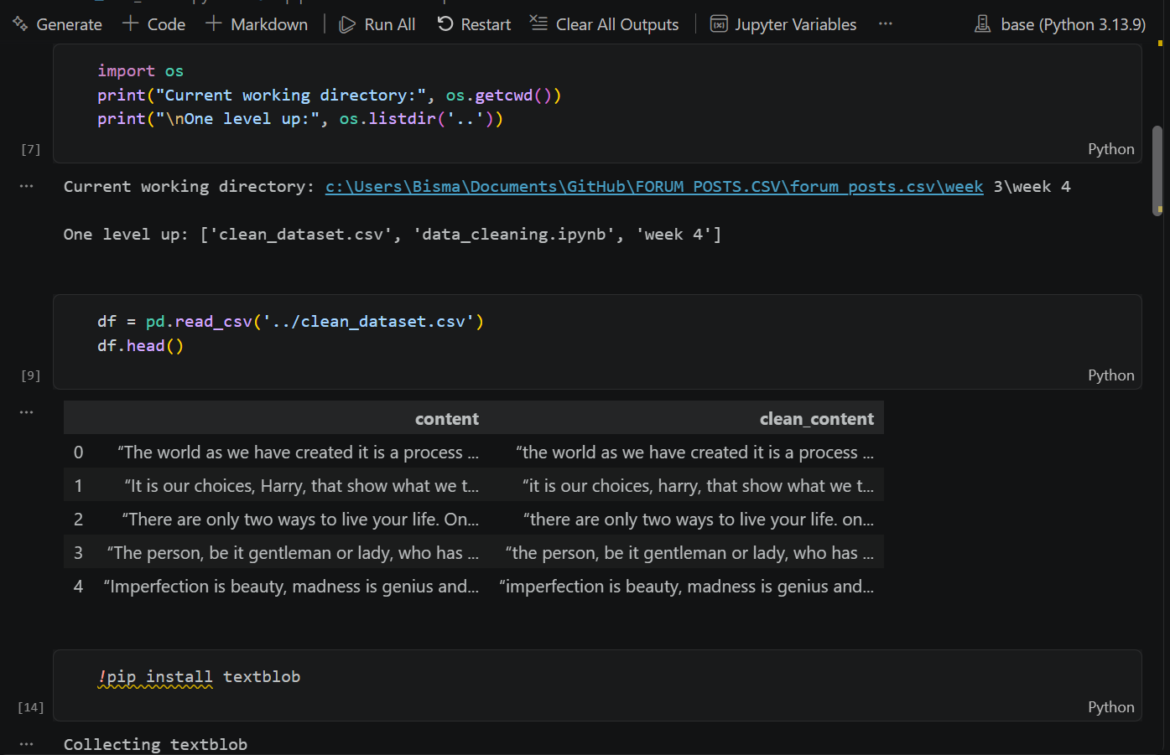
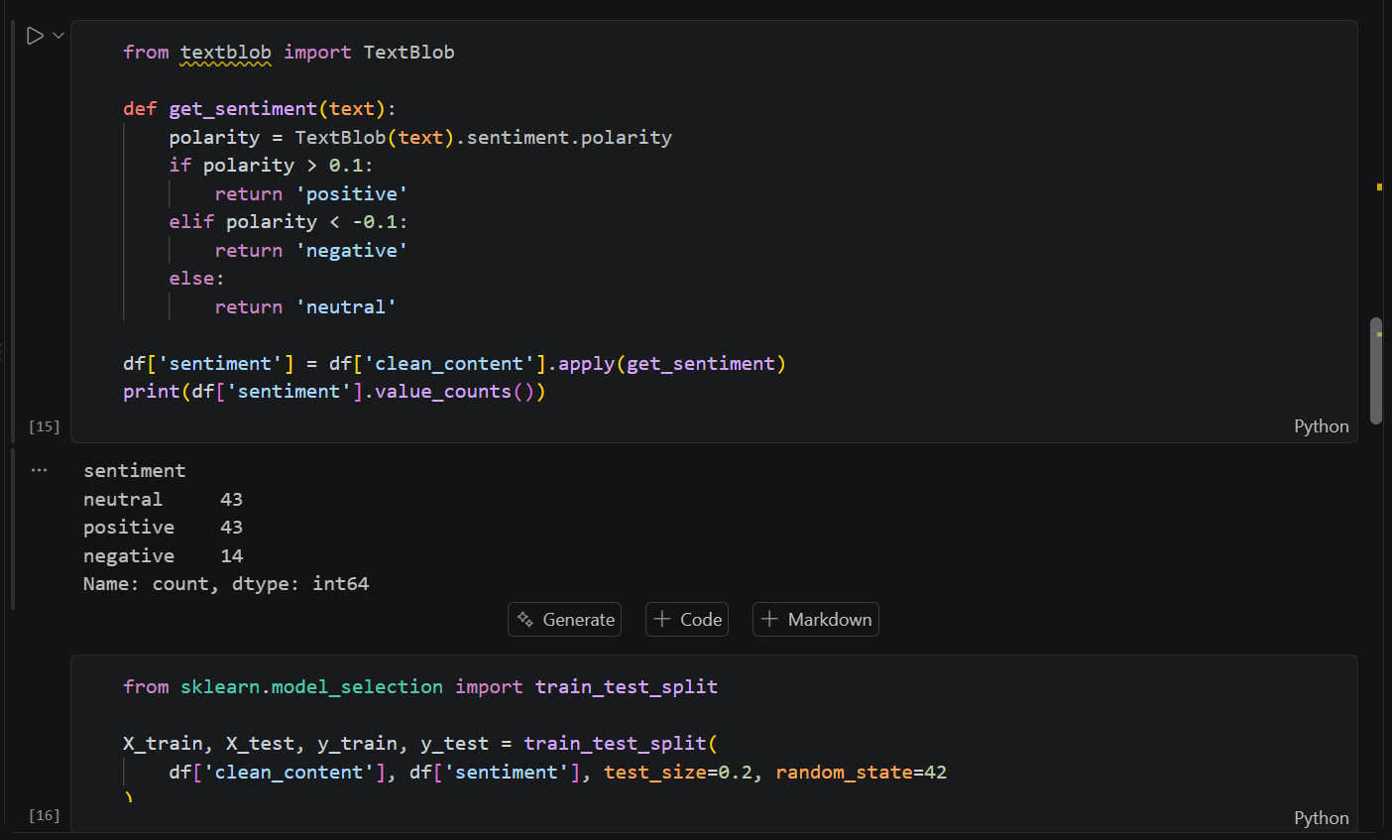

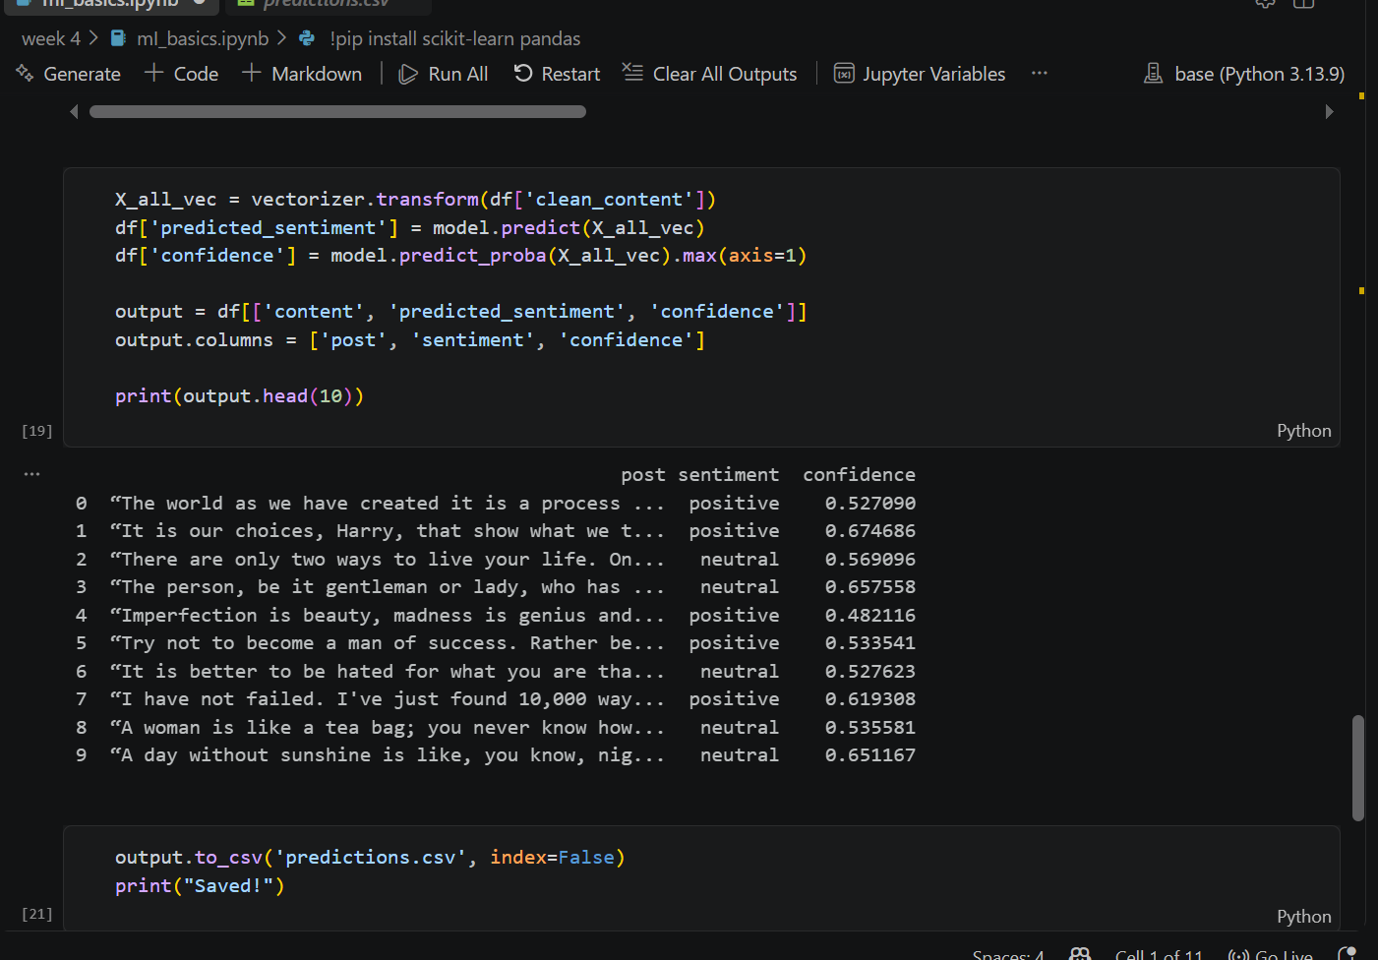
OUTPUT:
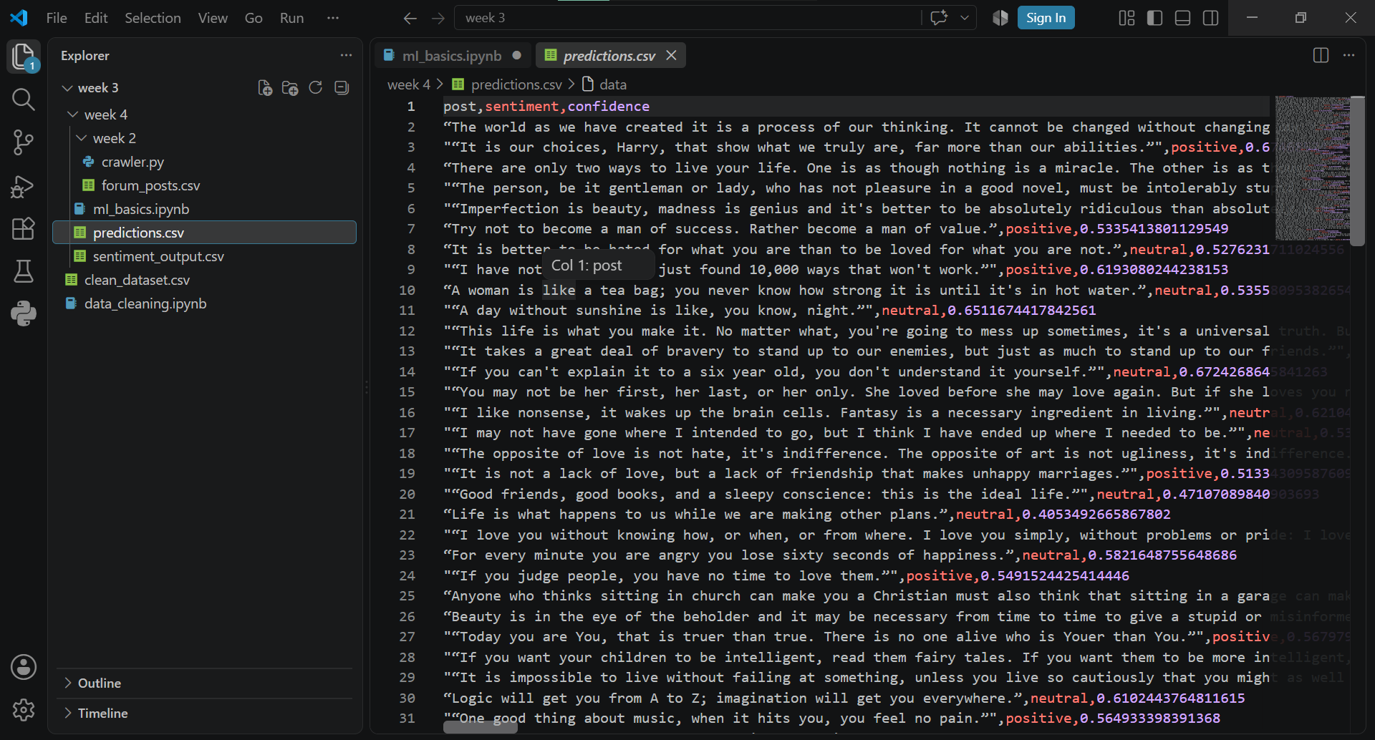
Conclusion
This task took me through the full journey of building a classifier — starting from raw text, labeling it, training a model on part of it, testing on the rest, and finally producing real predictions I could actually look at and evaluate.
What stood out most was realizing how much of ML is really about preparing the data properly — the actual training step was almost the easy part once the data was in the right shape. Even with a fairly small dataset, the model still managed to pick up on real patterns separating positive language from negative language, which was honestly satisfying to see work.
This was a solid step forward in understanding how classification models actually function in practice, not just in theory.

